**Project : Hospital and clinic management CRM**

***Phase 4 : Process Automation (Admin)***

1. ***Validation Rules***
2. Setup → Object Manager → Appointment__c → Validation Rules → New.
3. **Formula :**

Appointment_Date__c < TODAY()

1. Error Message: “Appointment date cannot be in the past.”
2. Set Error Location (field or page).

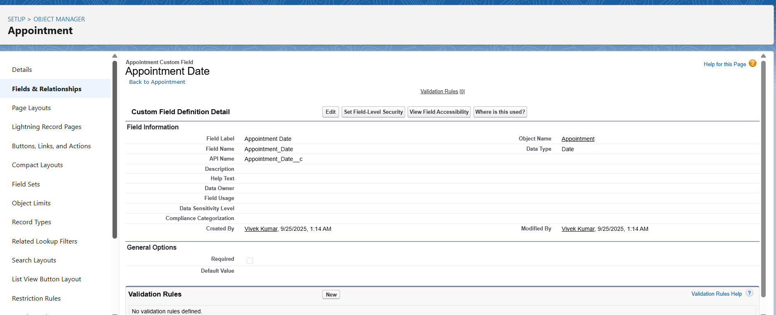

***Workflow Rules***

1. Setup → Workflow Rules → New Rule.
2. Select Object.
3. Set Evaluation Criteria → “created, and every time it’s edited.”
4. Add Rule Criteria.
5. Add Action → Email Alert / Field Update / Task.
6. Save → Activate.

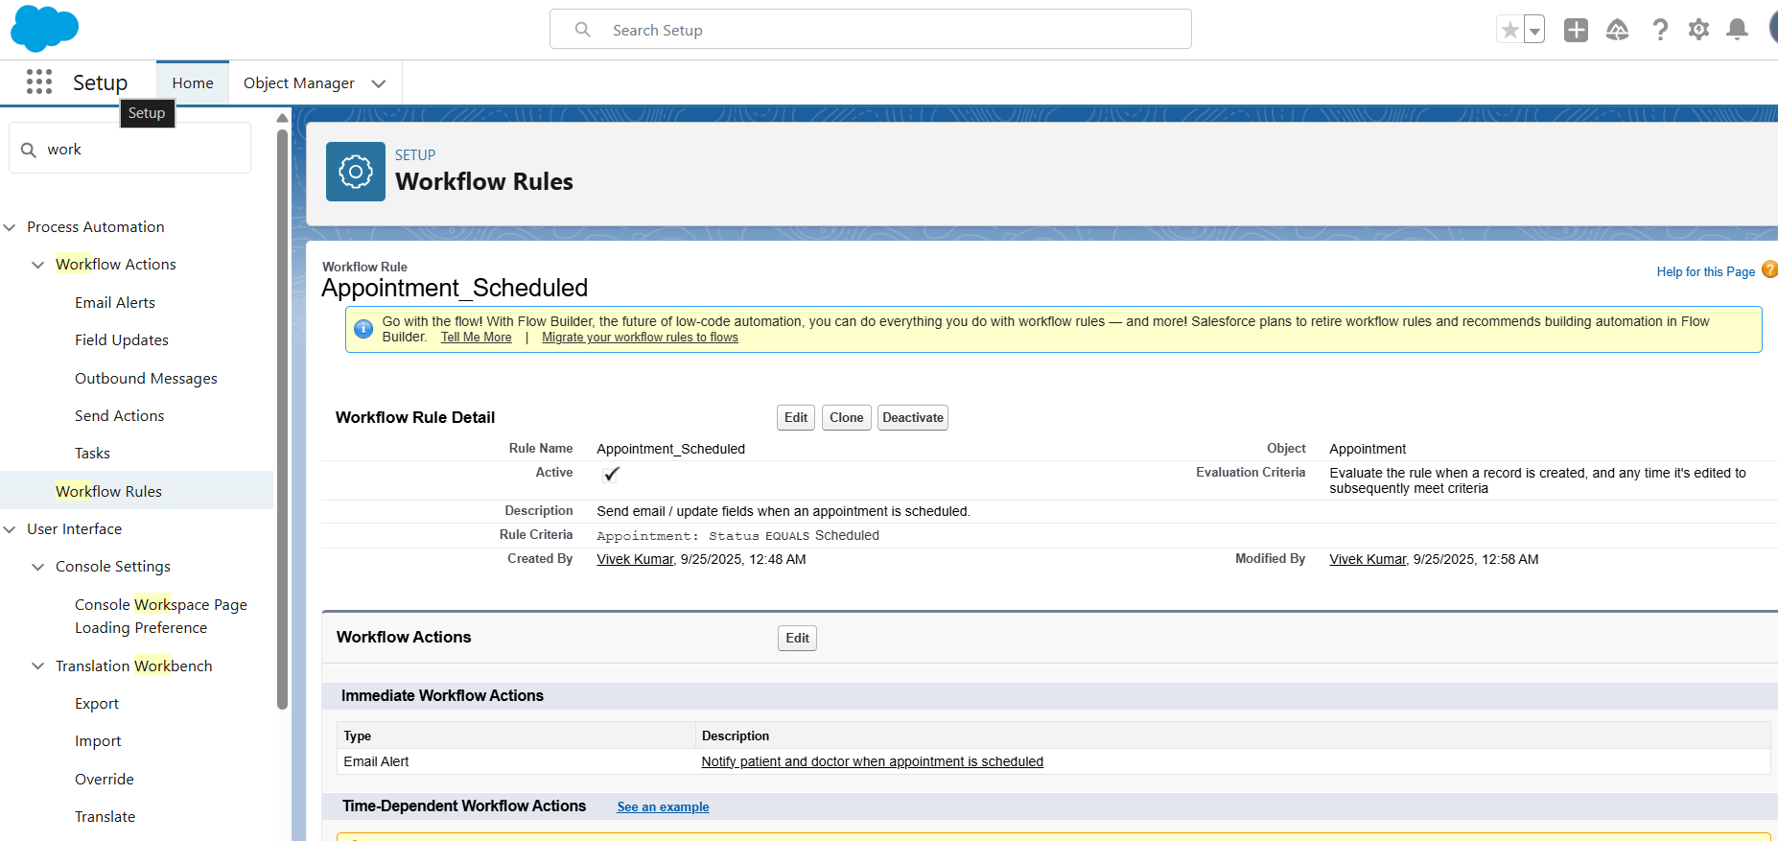

1. ***Process Builder***
2. Setup → Process Builder → New***.***
3. Enter Process Name → Choose Object
4. Define Trigger → “when record is created or edited.”
5. Add Criteria (e.g., always true).
6. Add Immediate Action → Update Records.
7. Save → Activate.

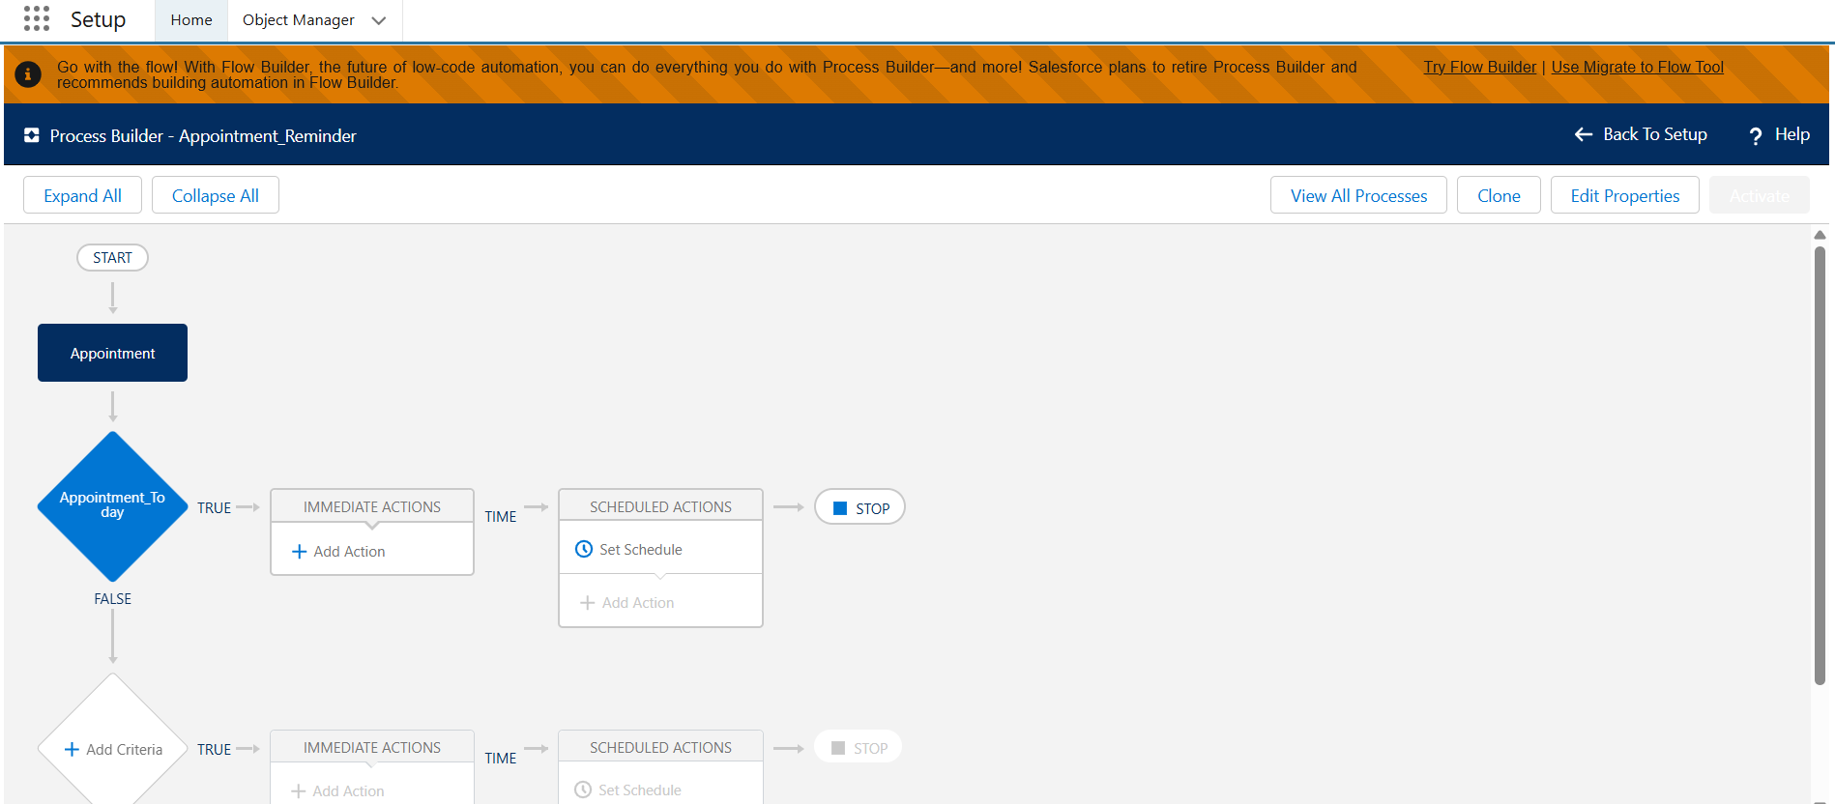

1. ***Approval Process***
2. Setup → Approval Processes → Choose Object (e.g., Payment__c).
3. Create New Approval Process → Use Standard Setup Wizard.
4. Set Entry Criteria
5. Define Approver(s) (specific user, role, or queue).
6. Configure Initial Submission Actions (lock record, send email).
7. Configure Final Approval/Final Rejection Actions.
8. Save → **Activate**.

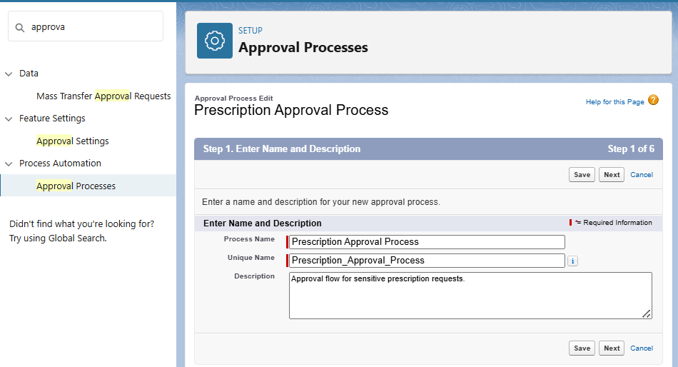

1. ***Flow Builder***
2. Setup → Flows → New Flow.
3. Choose Flow Type:
4. **Screen Flow:** interactive UI.
5. **Record-Triggered Flow:** runs on create/update/delete.
6. **Scheduled Flow:** runs on schedule.
7. **Auto-launched Flow:** runs in background.
8. Save → **Activate**.

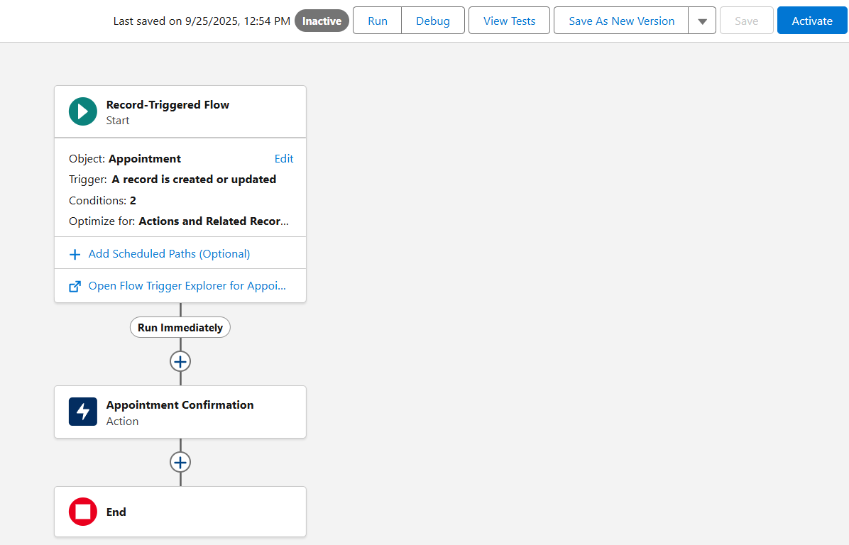

1. ***Email Alerts***
2. Setup → Email Alerts → New.
3. Select Object.
4. Choose Email Template + Recipient field.
5. Attach this to Workflow / Process Builder / Flow.
6. Save.

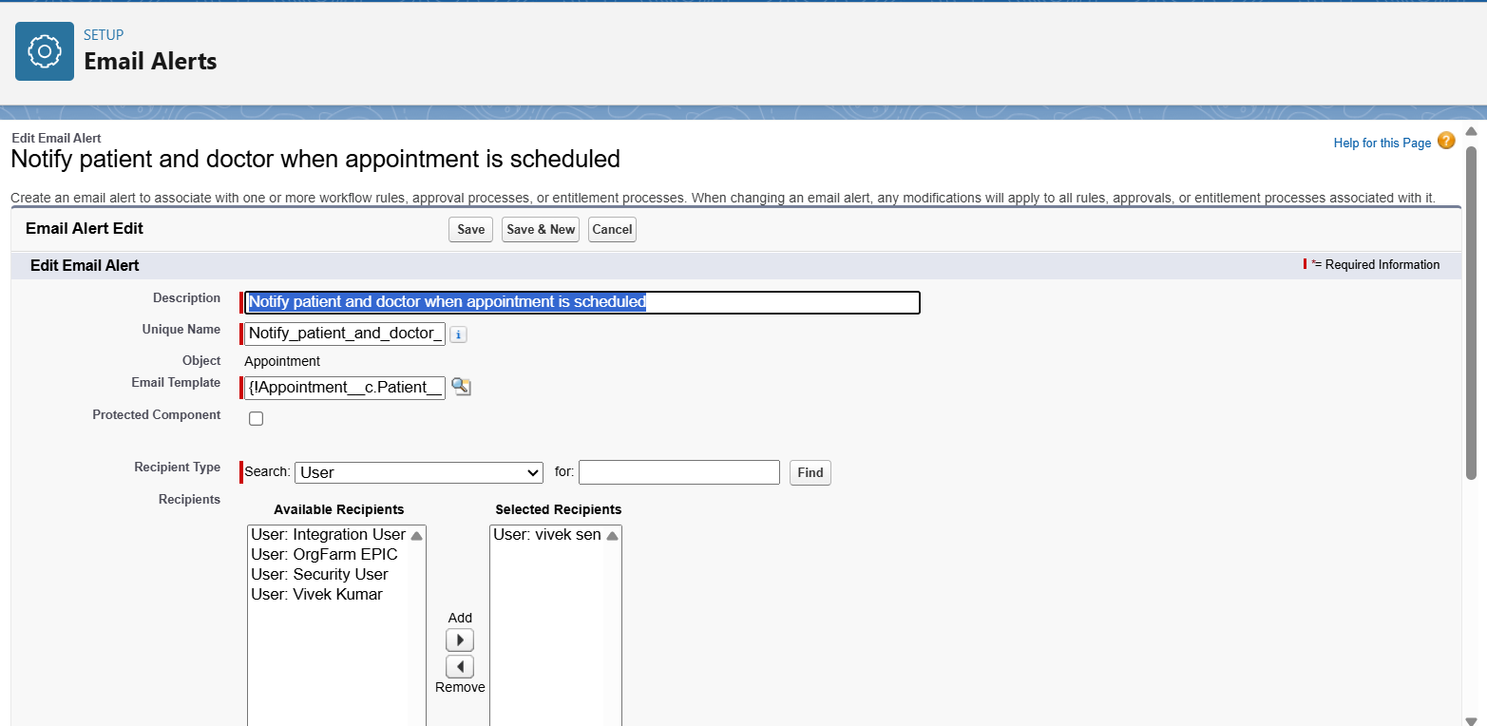

1. ***Field Updates***
2. Inside Workflow/Process Builder/Flow → Add Action → Field Update.
3. Choose Target Field.
4. Set New Value.
5. Save.

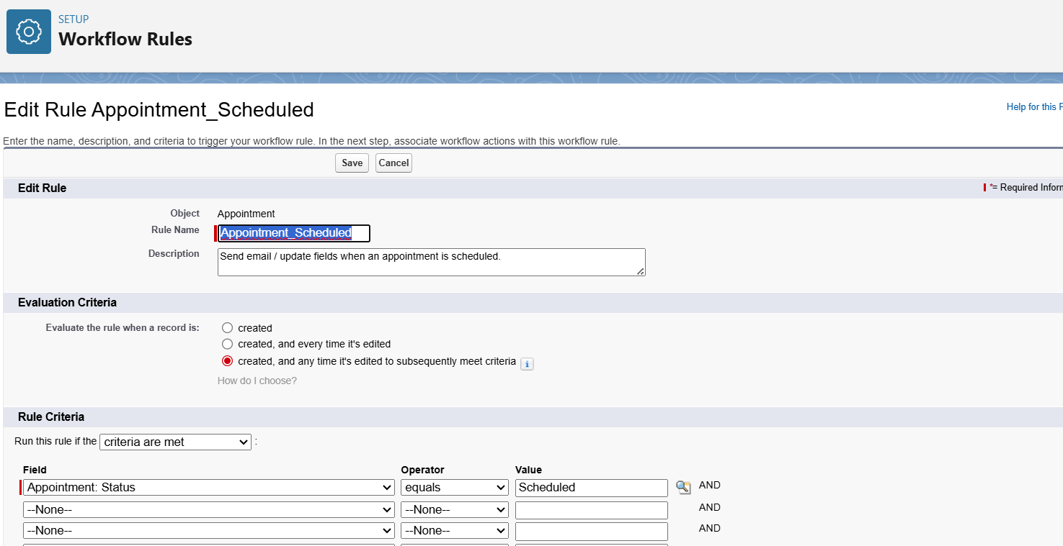

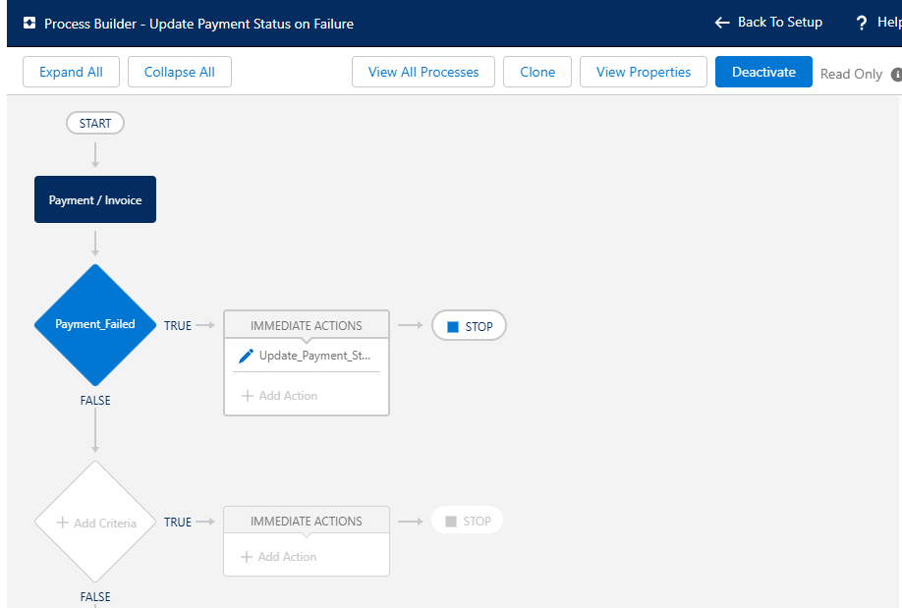

1. ***Custom Notifications***
2. Setup → Notification Builder → Custom Notifications → New.
3. Enter Name + API Name.
4. In Flow → Add Action → Send Custom Notification.
5. Select Recipient.
6. Save → Activate.

